13.Write a Pandas program to detect missing values of a given DataFrame. Display True or False.
Aim:
To write a Pandas program to detect missing values in a DataFrame and display True or False.
Program:
import pandas as pd
import numpy as np

data = pd.DataFrame({
"A": [10, 20, np.nan, 40],
"B": [15, np.nan, 35, 45],
"C": [25, 30, 35, np.nan],
"D": [40, 50, 60, 70]
})

print(data.isnull())
Output:
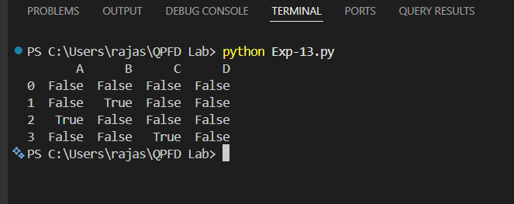
Result:
The program successfully detected the missing values in the DataFrame and displayed True for missing values and False for non-missing values.

14. Write a Pandas program to find and replace the missing values in a given DataFrame which do not have any valuable information.
Program:
import pandas as pd
import numpy as np
data = pd.DataFrame({
"A": [10, 20, np.nan, 40],
"B": [15, np.nan, 35, 45],
"C": [25, 30, 35, np.nan],
"D": [40, 50, 60, 70]
})

print("Original DataFrame:")
print(data)

data = data.fillna(0)
print("\nDataFrame after replacing missing values:")
print(data)
Output:
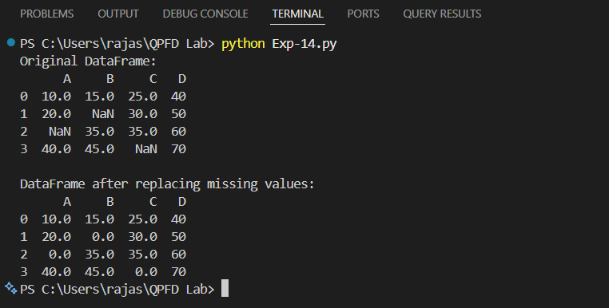
Result:
The program successfully found the missing values in the DataFrame and replaced them with 0 using the fillna() method.

